**PART A**

(PART A : TO BE REFFERED BY STUDENTS)

**EXPERIMENT NO. 7**

**A.1 AIM: -** To Implementing Predicting Energy Efficiency for Residential Buildings

**A.2 Prerequisite**

* Different programming language (Python or Java), Understanding of Machine Learning Algorithms, Machine Learning Algorithms

**A.3 Outcome**

After successful completion of this experiment students will be able to Optimize the problem.

**A.4 Theory**

**Multi-output linear model for prediction**

The linear model of interest is given by

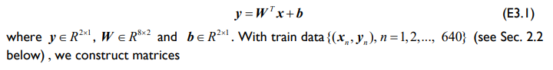

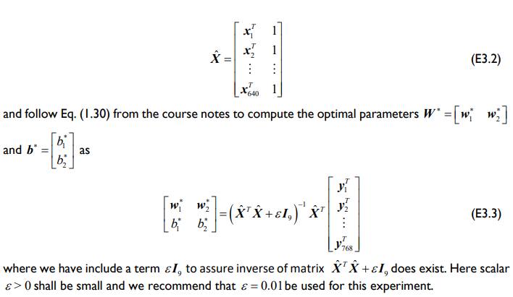

**A5. Task**

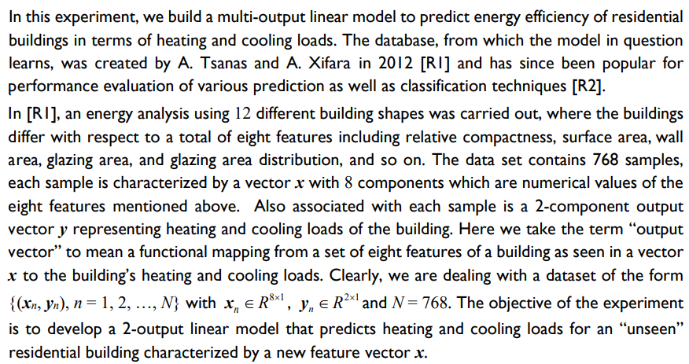

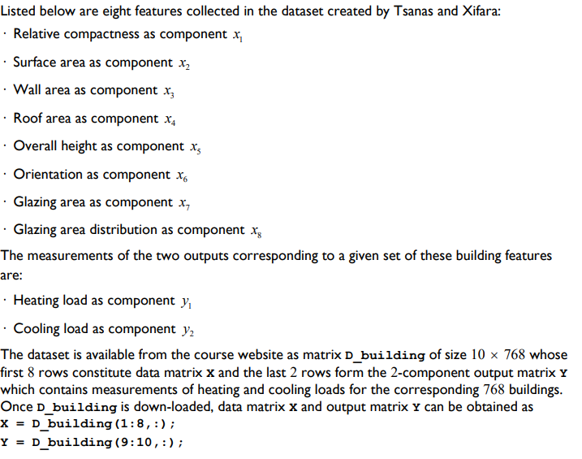

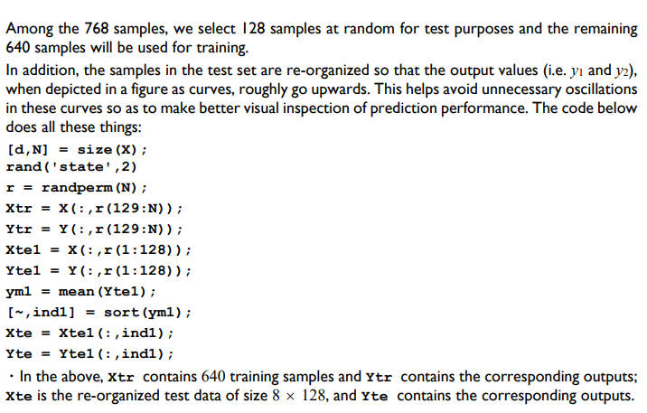

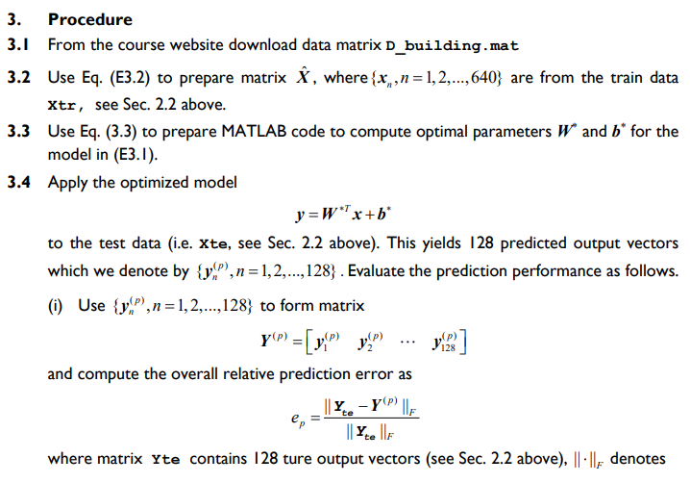

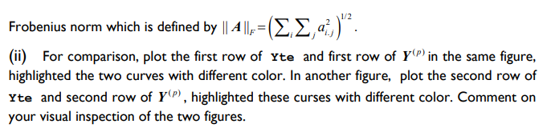

Links: <http://archive.ics.uci.edu/ml/datasets/Energy+efficiency?ref=datanews.io>

Or

<https://www.kaggle.com/datasets/elikplim/eergy-efficiency-dataset>

PART B

(PART B : TO BE COMPLETED BY STUDENTS)

***(Students must submit the soft copy as per following segments within two hours of the practical. The soft copy must be uploaded on the Blackboard or emailed to the concerned lab in charge faculties at the end of the practical in case there is no Black board access available)***

|  |  |
| --- | --- |
| Roll No: C027 | Name: Vishesh Giyanani |
| Class : B | Batch : EB1 |
| Date of Experiment: 29/03/24 | Date of Submission |
| Grade : |  |

**B.1 Documentation written by student:**

import pandas as pd

from sklearn.multioutput import MultiOutputRegressor

from sklearn.linear_model import Ridge, Lasso, LinearRegression

import seaborn as sns

from sklearn.model_selection import train_test_split

from sklearn.metrics import mean_squared_error, r2_score

import numpy as np

import matplotlib.pyplot as plt

data=pd.read_csv('ENB2012_data.csv')

data

corr = data.corr()

X,y = data.iloc[:,:-2].values.T, data.iloc[:,-2:].values.T

sns.heatmap(corr, *xticklabels*=corr.columns, *yticklabels* = corr.columns)

y.shape

d, N = X.shape

np.random.seed(2)

r = np.random.permutation(N)

Xtr = X[:, r[128:]]

Ytr = y[:, r[128:]]

Xtel = X[:, r[:128]]

Ytel = y[:, r[:128]]

ym1 = np.mean(Ytel, *axis*=1)

ind1 = np.argsort(ym1)

Xte = Xtel[:, ind1]

Yte = Ytel[:, ind1]

Xtr_tilde = np.vstack([Xtr, np.ones((1, Xtr.shape[1]))])

W = np.linalg.lstsq(Xtr_tilde.T, Ytr.T, *rcond*=None)[0]

Xte_tilde = np.vstack([Xte, np.ones((1, Xte.shape[1]))])

Yp = np.dot(W.T, Xte_tilde)

error = np.linalg.norm(Yte - Yp, 'fro') / np.linalg.norm(Yte, 'fro')

plt.figure(*figsize*=(10, 8))

plt.subplot(2, 1, 1)

plt.plot(Yte[0, :], 'b', *linewidth*=2)

plt.plot(Yp[0, :],'r--', *linewidth*=2)

plt.title('Heating Load Prediction')

plt.legend(['True Heating Load', 'Predicted Heating Load'])

plt.figure(*figsize*=(10, 8))

plt.subplot(2, 1, 2)

plt.plot(Yte[1, :], 'g', *linewidth*=2)

plt.plot(Yp[1, :],'m--', *linewidth*=2)

plt.title('Cooling Load Prediction')

plt.legend(['True Cooling Load', 'Predicted Cooling Load'])

X_train,X_test,y_train,y_test = train_test_split(X.T,y.T,*random_state* = 42,*test_size* = 0.2)

regr = MultiOutputRegressor(Ridge(*random_state*=123)).fit(X_train, y_train)

linear = MultiOutputRegressor(LinearRegression()).fit(X_train, y_train)

lasso = MultiOutputRegressor(Lasso(*alpha*=4)).fit(X_train, y_train)

models = [regr, linear, lasso]

preds = []

names = {

1: "Ridge",

2: "Linear Regression",

3: "Lasso"

}

for i,model in enumerate(models):

preds = model.predict(X_test)

print(f"The MSE for {names[i+1]} is: {mean_squared_error(y_test,preds)}")

print(f"The R2 score for {names[i+1]} is: {r2_score(y_test,preds)}")

print("-"*20)

print()

y_pred = linear.predict(X_test)

plt.figure(*figsize*=(10, 8))

plt.subplot(2, 1, 1)

plt.plot(y_test[0, :], 'b', *linewidth*=2)

plt.plot(y_pred[0, :],'r--', *linewidth*=2)

plt.title('Heating Load Prediction')

plt.legend(['True Heating Load', 'Predicted Heating Load'])

plt.figure(*figsize*=(10, 8))

plt.subplot(2, 1, 2)

plt.plot(y_test[1, :], 'g', *linewidth*=2)

plt.plot(y_pred[1, :],'m--', *linewidth*=2)

plt.title('Cooling Load Prediction')

plt.legend(['True Cooling Load', 'Predicted Cooling Load'])

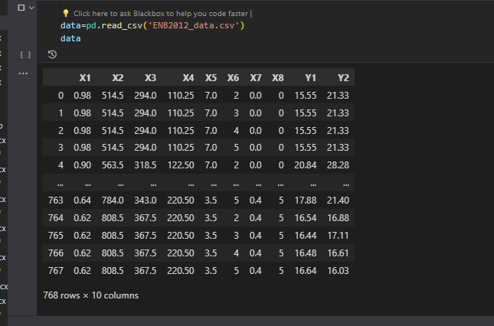

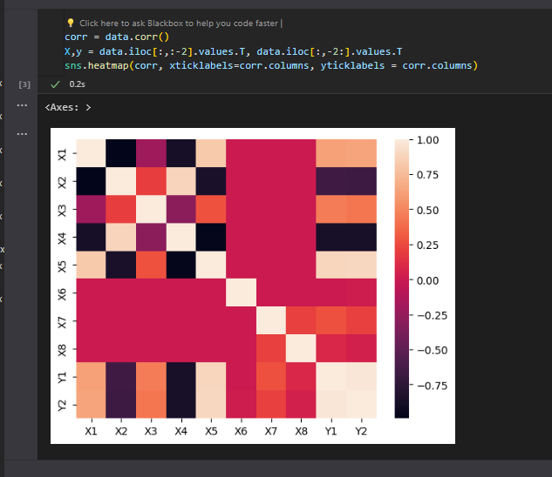

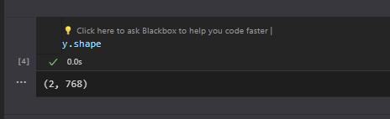

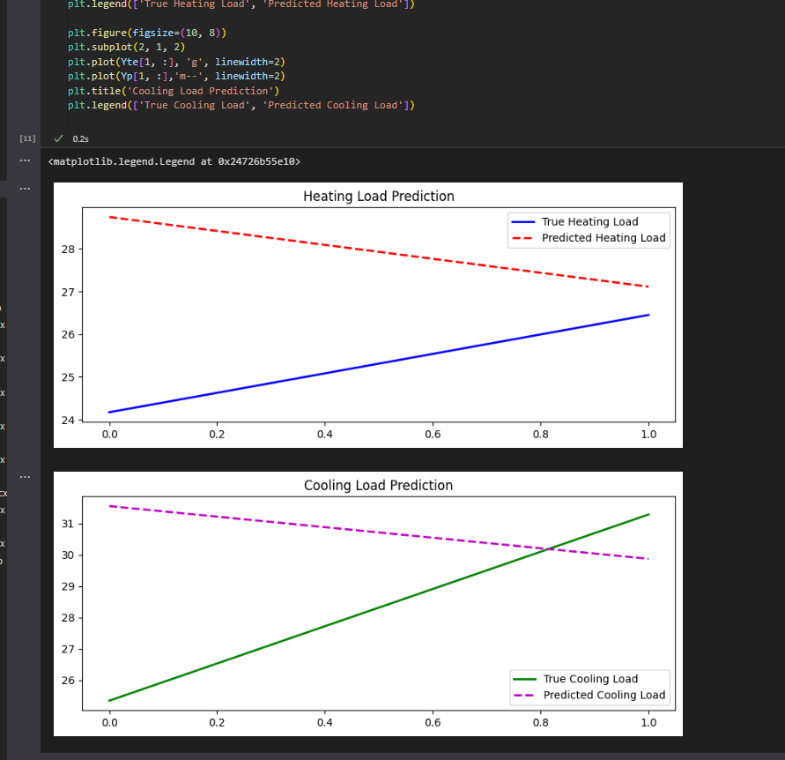

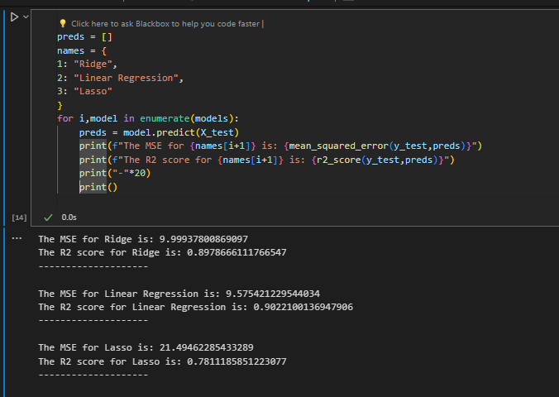

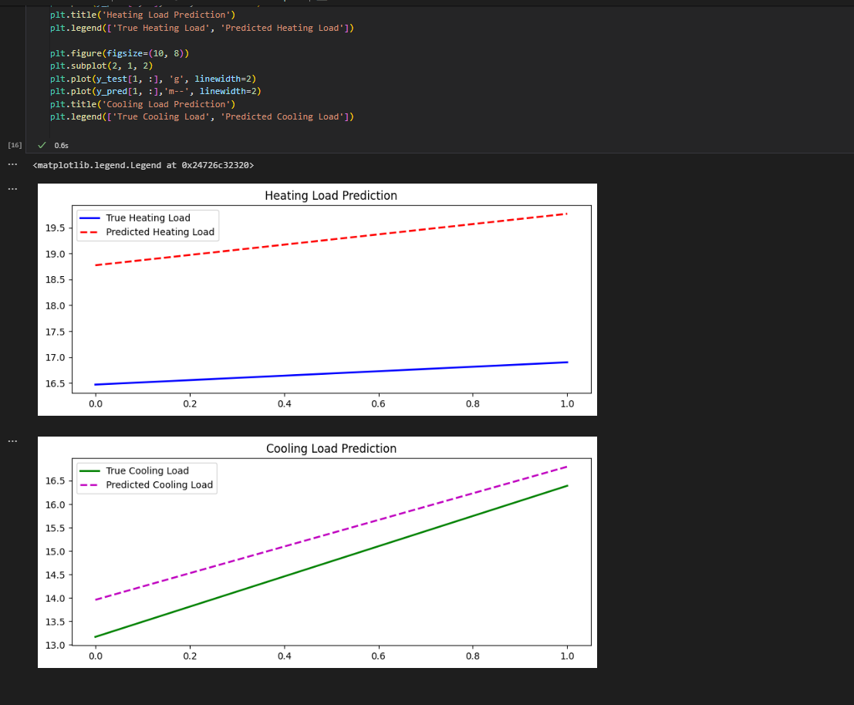

**B.2 Observations and learning:**

In multi-output regression with linear regression, feature selection identifies crucial predictors for multiple outputs, enhancing model performance. Regularization techniques like Lasso or Ridge regression mitigate overfitting, refining the model's ability to generalize across outputs. These steps are pivotal for accurate predictions across multiple variables, ensuring the model's effectiveness.

**B.3 Conclusion:**

Using linear regression for multi-output models works well when you apply preprocessing, select important features, and use regularization techniques. By choosing the right features and preventing overfitting, the model can accurately predict multiple outputs. This emphasizes the need for thoughtful model design and parameter adjustment to ensure strong performance in complex regression tasks.